Mother’s Day Raffle Giveaway
Deadline May 13th
Who is eligible:
Any mother or mother figure gets an automatic entry, however all are welcome to participate.
How do you enter:
Be on time for your appointment (moms only) 1 ticket
Refer a loved one 10 tickets
Leave a review on our website 20 tickets
Leave a Google review 25 tickets
Bring your children in for an exam 40 tickets
Purchase a Mother’s Day Gift Exam 50 tickets
What is the prize:
The prize is currently at a $300 value and growing.
Including DoTerra Aromatherapy Diffuser and Oils
2 Tickets to The Fish Family Fest Concert
Healthy Cooking Spices
vouchers, books, skin care products and more
Winner Announced May 14!

Calendar at a Glance
May 1st-13th - Mother’s Day Raffle Giveaway
May 2nd - Nutritional Workshop/Cleanse Introduction Class
May 8th - Better Results Faster Class 1: Home Care @ 6:00 pm
May 9th - Cleanse Starter Webinar
May 9th - Closed
May 13th - Start Cleanse
May 14th - Mother’s Day winner announced
May 16th - Detox Support Webinar
May 22nd - Better Results Faster Class 2: Form & Function @ 6:00 pm
May 23rd - Life After Detox Support Webinar
May 23rd - Closed
May 27th - Closed for Memorial Day
May 28th - Dinner with the Doc
WE LOVE MOMS
This May earn tickets for that special woman by participating in the Mother’s Day Raffle Giveaway. See attached flyer & front desk for details.

May16th - Webinar
(You can log on from any PC or smart device. )
Ok good, you got through day 4? Looking for tips on how to optimize your results? Join us for the
TOP 10
Detox Support Tips
May 23rd - Webinar
(You can log on from any PC or smart device.)
YOU DID IT! Great job! But now what? We’ve got your back. Join our support webinar,
Life After Detox
and learn tips for maintaining a healthy balanced wellness regimen.

For more info Register Online:
myrcc.com/upcoming-events

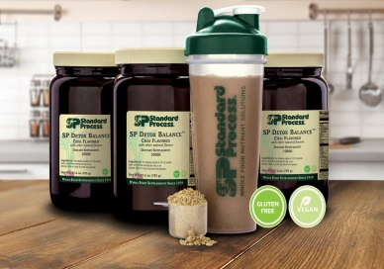
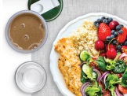
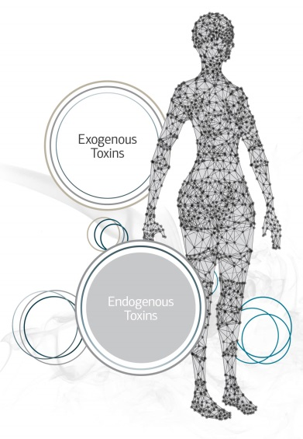
MAY 2nd
TOXIC TOXINS EVERYWHERE!
Come learn ways to protect yourself and your family with detox and nutritional support that create optimal health through lifestyle
changes.

RCC Lobby Hosted by
Dr. Ken Moger @ 5:30 pm
May 9th Webinar
(You can log on from any PC or smart device. )
Join us for a deep dive of what to expect and the best practices to follow while on your detox.
For more info Register Online:
myrcc.com/upcoming-events
May 14th
The winner of this year’s Mother’s Day Raffle Giveaway will be announced online at myrcc.com/upcoming-events under RCC NEWSLETTERS.

